# Activity 1: What is it?

## Cookies

You are creating a database of chocolate-chip cookie recipes.

What is a chocolate-chip cookie? Write a definition.

Open the accompanying Cookies file. There are 8 cookie recipes. (Each has a number at the top.)

Which of the recipes should be included in your database, according to your definition of *chocolate chip cookie?*

|  |  |  |  |
| --- | --- | --- | --- |
| **Number** | **Cookie Name** | **Include in Database?** | **Rationale for Decision** |
|  |  |  |  |
|  |  |  |  |
|  |  |  |  |
|  |  |  |  |
|  |  |  |  |
|  |  |  |  |
|  |  |  |  |
|  |  |  |  |

Do you want to revise your definition? How would you revise it?

Is your definition sufficient to enable a computer to collect all the “chocolate chip cookie recipes” on the Web?

## Documentation of events

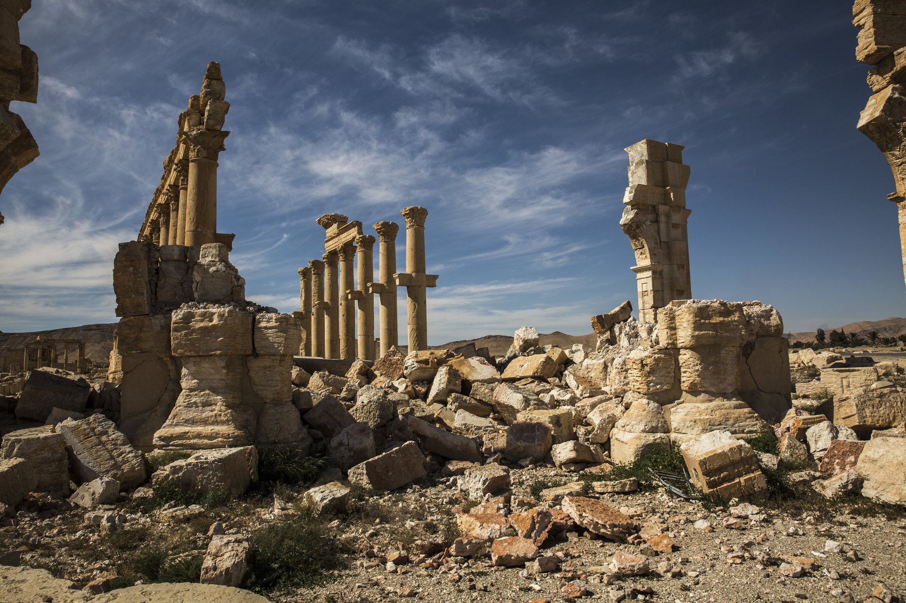

|  |  |
| --- | --- |
| **Element** | **Value** |
| Photographer | Bryan Denton |
| Event | Destruction of Decumanus Maximus in Palmyra, Syria |
| Event Type | Bombing/explosion |
| Actor | ISIS |
| Actor | Syrian Army |
| Event Date | 2015 |
| Source Date | April 4, 2016 |
| File Date | April 29, 2016 |
| Source | New York Times |
| Format | JPEG |
| File size | 803 KB |
| Filename | Decumanus example.jpg |

What does this record describe?

How might this record structure affect subsequent information use?

## Violence against civilians

You are compiling data from a variety of sources to track violence that targets civilians in Somalia.

The following event is described in both ACLED (Armed Conflict Location and Event Data Project) and GTD (Global Terrorism Database). Should you include it in your dataset?

### ACLED source data

The ACLED dataset *only* includes events that are “armed conflicts.” *All* of the entities in ACLED are defined as incidents of political violence that involve “the use of force by a group with a political purpose or motivation.”

| **Element** | **Value** |
| --- | --- |
| Event type | Battle without exchange of territory |
| Actor 1 | Marine Police Forces of Puntland |
| Actor 2 | Majeerteen Clan Militia (Somalia) |
| Interaction type | military vs. communal militia |
| Fatalities | 7 |
| Wounded | 37 |
| Location | Bosaso city, Bari region, Somalia |
| Summary | A person-borne IED targeted a Puntland Marine Police Forces (PMPF) convoy near Rowda Mosque in Bosasso in the morning of 05/12. Reports indicate that two foreign trainers working for Seracen were in the convoy. Seven people - three soldiers and four civilians - were killed in attack. A total of 37 persons, six soldiers and 31 civilians, were also wounded. The two trainers were unhurt. Latest reports on 07/12 indicate that the suicide bomber hails from Majeerten and came from Kismaayo. |
| Date | 12/05/2013 |
| Source | Local source project |

### GTD source data

The GTD dataset *only* includes “terrorist attacks.” *All* of the entities in GTD are defined as “the threatened or actual use of illegal force and violence by a non-state actor to attain a political, economic, religious, or social goal through fear, coercion, or intimidation.”

| **Element** | **Value** |
| --- | --- |
| Attack type | Bombing/explosion |
| Perpetrators | Al-Shabaab |
| Target 1 | Puntland Marine Forces |
| Target 1 Type | Military |
| Target 2 | Civilians |
| Target 2 Type | Private citizens and property |
| Fatalities | 9 |
| Wounded | 37 |
| Location | Bosaso city, Bari region, Somalia |
| Summary | A suicide bomber rammed an explosives-laden vehicle into two trucks of the Puntland Marine Forces in Bosaso city, Bari region, Somalia. The convoy was escorting foreign workers. In addition to the assailant, nine people were killed and 37 others were wounded in the attack. No group claimed responsibility for the incident; however, authorities attributed the attack to Al-Shabaab. |
| Date | 12/05/2013 |
| Sources | Associated Press, Reuters, Whistler Question |

Should you include this event in your dataset of violence that targets civilians in Somalia?

How would you create an entity definition in a data management plan that clarifies the events that would appropriately be included in this dataset?